**Software Requirements**

**Specification**

**for**

**Advanced Restaurant Management System**

**Version 1**

**Prepared by Dylan Stein, Emma Bellai, Donghao Li, Weiwei Zhang**

**Syracuse University CIS453**

**October 15, 2023**

Table of Contents

1. Introduction...........................................................................................................................................3
   1. Purpose..........................................................................................................................................3
   2. Scope.............................................................................................................................................3
   3. Definitions.....................................................................................................................................4
   4. Overview........................................................................................................................................
2. Overall Description................................................................................................................................
   1. Product Perspective........................................................................................................................
   2. Product Functions...........................................................................................................................
   3. Use Case Descriptions...................................................................................................................
      1. Device Integration………………………………………………………………………
         1. Assumptions………………………………………………………………………
      2. Automation and Customization……………………………………………………………
         1. Assumptions………………………………………………………………………
      3. Remote Control and Monitoring………………………………………………………………
         1. Assumptions………………………………………………………………………
      4. Energy Management and Insight……………………………………………………
         1. Assumptions…………………………………………………………
3. Specific Requirements..............................................................................................................................
   1. Overview......................................................................................................................................
   2. Interface Requirements.................................................................................................................
   3. System Features............................................................................................................................
   4. Performance Requirements...............................................................................................................
   5. Design Constraints............................................................................................................................
   6. Software System Attributes..............................................................................................................
   7. Other Requirements..........................................................................................................................

**Table of Figures**

Figure 1 - System Block Diagram................................................................................................................

Figure 2 Smart Home Automation Hub Use Cases.......................................................................................

Figure 3 – Automation Hub Activities……………………………………………………………………….

**Table of Tables**

Table 1 – Acronyms and Definitions.................................................................................................................................................

|  |  |  |  |
| --- | --- | --- | --- |
| **Name** | **Date** | **Reason for Changes** | **Version** |
| Team 6 | 9/20/2023 | Initial Revision | **--** |
| Team 6 | 10/15/2023 | Added Activity Diagram  Added Requirements  Updated Block Diagram  Added Detailed Use Cases  Added Use Case Diagrams  Added Activity Diagram | 01 |

1. Introduction
   1. Purpose

The Restaurant Management System Software Requirements Specification (SRS) serves as a comprehensive guide for developers responsible for creating the application and for the testing team tasked with designing Verification and Validation (V&V) plans and procedures. This SRS outlines the essential software requirements, ensuring that the resulting application aligns with this specification.

* 1. Scope

This document delineates the extensive scope of the Restaurant Management System project, encompassing but not limited to:

1. Device Integration: This entails the integration of various smart technologies, such as Internet of Things (IoT) devices and artificial intelligence, to streamline restaurant operations and enhance customer experiences.
2. Business Process Optimization: The system aims to optimize various restaurant processes, including reservation management, menu creation, inventory management, and customer support through AI chatbots.
3. Data Analysis and Insights: The system will provide valuable data analysis capabilities, allowing restaurant owners to make informed decisions, such as menu adjustments and supply management, based on real-time customer feedback and trends.
4. Enhanced Customer Experience: Customers will benefit from digital menus, mobile app integration, and streamlined payment processing, all of which contribute to a more convenient and satisfying dining experience
   1. Definitions

Table 1 Acronyms and Definitions

**Software Requirements Specification (SRS)**: A detailed document outlining the software requirements for a project, serving as a blueprint for development.

**Internet of Things (IoT):** The interconnected network of smart devices that communicate and can be controlled remotely, forming the backbone of our system.

**Application Programming Interface (API):** A set of protocols and tools for building software applications, facilitating integration with external services.

**Cloud Computing:** The delivery of various computing services, including data storage and management, over the internet.

**Artificial Intelligence (AI):** The simulation of human intelligence processes by machines, which may play a role in the development of our system.

**Verification and Validation (V&V):** The process of ensuring that the software functions correctly and meets the specified requirements.

**Transmission Control Protocol (TCP):** A fundamental communication protocol for transmitting data over the internet.

**Unified Modeling Language (UML):** A standardized modeling language for visualizing and documenting software systems.

**Internet of Things (IoT):** The interconnected network of smart devices that communicate and can be controlled remotely, forming the backbone of our system.

**BDD**: Block Definition Diagram, a graphical tool for modeling the system's structure.

**API**: Application Programming Interface, a set of protocols and tools for building software applications.

**AWS**: Amazon Web Services, a cloud computing platform offering various services.

**Azure**: Microsoft's cloud computing service offering a range of cloud-based solutions.

**AI**: Artificial Intelligence, the simulation of human intelligence processes by machines.

* 1. Overview

The Restaurant Management System Software Requirements Specification follows the recommended format as specified in IEEE Std 830-1998, the IEEE Recommended Practice for Software Requirements Specifications. To ensure clarity and organization, Section 3 adheres to the template A.5 for organizing information by feature, providing a clear roadmap for development and testing teams to successfully complete the project.

1. Overall Description
   1. Product Perspective

The Restaurant Management System (RMS) is envisioned as a central hub for modern restaurant operations, offering a pivotal role within the restaurant's operational environment. This application serves as the cornerstone for restaurants aiming to harness technology, automation, and data-driven insights to streamline their daily activities and enhance the dining experience. In many instances, the RMS serves as the primary means through which restaurant owners, staff, and customers interact with various restaurant-related processes and services. It acts as the gateway to utilizing advanced technology, managing reservations, creating and updating digital menus, optimizing inventory, and engaging in data-driven decision-making. The RMS seamlessly integrates with external services, IoT devices, and mobile apps, creating a cohesive ecosystem that enhances restaurant operations and customer satisfaction.

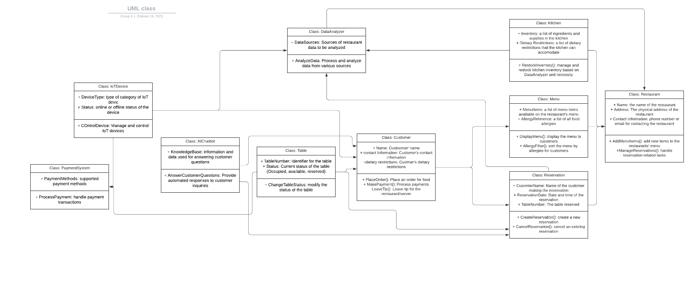

* 1. Product Functions

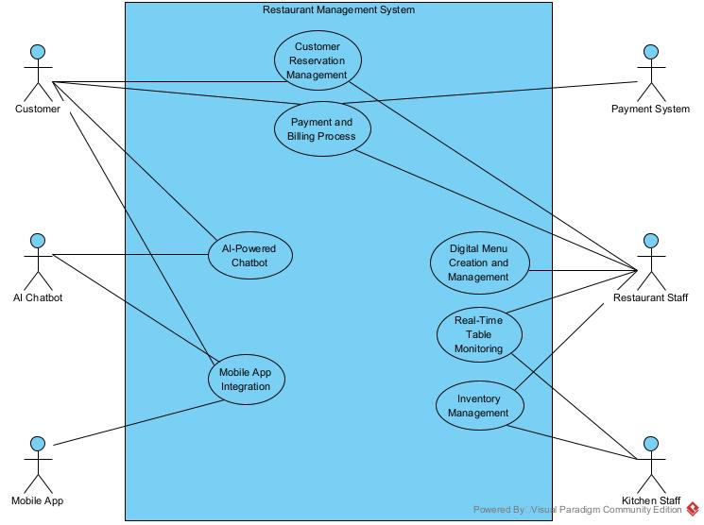The system’s functionality is comprehensively depicted in the following use case diagram, which outlines the various ways in which users will interact with the Advanced Restaurant Management System

* 1. Use Case Descriptions

|  |  |
| --- | --- |
| **General Characteristics** | |
| **Intent** | Enable customers to make, modify, and cancel reservations at the restaurant. |
| **Scope** | Restaurant Reservation System |
| **Primary Actor** | Customer |
| **Secondary Actors** | Restaurant |
| **Preconditions** | The restaurant is accepting reservations. |
| **2.3.1.1 Assumptions** | The customer has internet access, and the reservation system is accessible online. |
| **Trigger** | The customer wants to make a reservation |
| **Success Post Condition** | The customer successfully manages their reservation |
| **Failed Post Condition** | The reservation process fails due to system error or full booking |

* + 1. Customer Reservation

Sunny Day Scenario

|  |  |
| --- | --- |
| Step | Action |
| Start | The scenario begins when a customer decides to make a reservation |
| 1 | The customer access the reservation system |
| 2 | The system displays available time slots |
| 3 | The customer selects the desired time and inputs the required details |
| 4 | The system confirms the reservation |
| 5 | The customer receives a confirmation notification |

Rainy Day Scenario

|  |  |
| --- | --- |
| Step | Action |
| Start | The scenario begins when a customer decides to make a reservation |
| 1 | The customer access the reservation system |
| 2 | The system fails to load due to a technical glitch |
| 3 | The customer retries accessing the system |
| 4 | The desired slot gets fully booked during the wait |
| 5 | The customer chooses an alternative time or exits without booking |

* + 1. Digital Menu Creation and Management

|  |  |
| --- | --- |
| **General Characteristics** | |
| **Intent** | Allow the restaurant to create, modify, and display a digital menu. |
| **Scope** | Restaurant Management System |
| **Primary Actor** | Restaurant Staff |
| **Secondary Actors** | None |
| **Preconditions** | The restaurant operates digitally and can display online menus. |
| **2.3.2.1 Assumptions** | The staff has access to the management system and the required menu details |
| **Trigger** | The staff wants to modify or create a new menu. |
| **Success Post Condition** | The digital menu is successfully created/updated. |
| **Failed Post Condition** | The menu modification or creation fails due to a system error |

Sunny Day Scenario

|  |  |
| --- | --- |
| Step | Action |
| Start | The scenario begins when the restaurant staff decides to modify the digital menu. |
| 1 | The staff accesses the menu management system. |
| 2 | The system displays the current menu. |
| 3 | The staff makes desired changes or adds new items. |
| 4 | The system saves and updates the menu. |
| 5 | The updated menu is made live for customers. |

Rainy Day Scenario

|  |  |
| --- | --- |
| Step | Action |
| Start | The scenario begins when the restaurant staff decides to modify the digital menu. |
| 1 | The staff accesses the menu management system. |
| 2 | The system fails to load the current menu. |
| 3 | The staff retries after some time or contacts IT support. |
| 4 | The changes are not saved due to a system glitch. |
| 5 | The staff needs to redo the changes or delay the update. |

* + 1. Inventory Management

|  |  |
| --- | --- |
| **General Characteristics** | |
| **Intent** | Enable the restaurant to monitor, add, or remove inventory items. |
| **Scope** | Restaurant Inventory System |
| **Primary Actor** | Kitchen Staff |
| **Secondary Actors** | Suppliers |
| **Preconditions** | The restaurant operates with an inventory management system. |
| **2.3.3.1 Assumptions** | The kitchen staff has access to the inventory system. |
| **Trigger** | The kitchen staff wants to update the inventory or check stock levels. |
| **Success Post Condition** | Inventory is successfully updated/checked. |
| **Failed Post Condition** | Inventory update/check fails due to system error or missing items. |

Sunny Day Scenario

|  |  |
| --- | --- |
| Step | Action |
| Start | The scenario begins when kitchen staff decides to check or update inventory. |
| 1 | The staff accesses the inventory system. |
| 2 | The system displays current stock levels. |
| 3 | The staff updates stock counts or adds new items. |
| 4 | The system saves the changes. |
| 5 | The updated inventory data is reflected in the system. |

Rainy Day Scenario

|  |  |
| --- | --- |
| Step | Action |
| Start | The scenario begins when kitchen staff decides to check or update inventory. |
| 1 | The staff accesses the inventory system. |
| 2 | The system displays incorrect or outdated stock levels. |
| 3 | The staff rechecks physical stock and finds discrepancies. |
| 4 | The staff logs a system issue or contacts IT support. |
| 5 | Inventory updates are delayed until the issue is resolved. |

* + 1. Real-Time Table Monitoring

|  |  |
| --- | --- |
| **General Characteristics** | |
| **Intent** | Monitor the status of tables (occupied, available, reserved) in real-time. |
| **Scope** | Restaurant Table Management System |
| **Primary Actor** | Restaurant Staff |
| **Secondary Actors** | Customers |
| **Preconditions** | The restaurant operates with a table monitoring system. |
| **2.3.4.1 Assumptions** | The staff has access to the table monitoring interface. |
| **Trigger** | Staff wants to check table availability or update table status. |
| **Success Post Condition** | Table status is successfully viewed/updated. |
| **Failed Post Condition** | Table monitoring system malfunctions or provides incorrect info. |

Sunny Day Scenario

|  |  |
| --- | --- |
| Step | Action |
| Start | The scenario begins when the staff decides to monitor or update table statuses. |
| 1 | The staff accesses the table monitoring interface. |
| 2 | The interface displays current table statuses. |
| 3 | Staff updates the status of a table if needed. |
| 4 | Staff updates the status of a table if needed. |
| 5 | Staff continues their tasks with the updated table info. |

Rainy Day Scenario

|  |  |
| --- | --- |
| Step | Action |
| Start | The scenario begins when the staff decides to monitor or update table statuses. |
| 1 | The staff accesses the table monitoring interface. |
| 2 | The system fails to load table data or shows outdated info. |
| 3 | Staff manually checks table statuses and finds discrepancies. |
| 4 | Staff logs the issue or contacts IT support. |
| 5 | Manual monitoring continues until the system issue is resolved. |

* + 1. Mobile App Integration

|  |  |
| --- | --- |
| **General Characteristics** | |
| **Intent** | Enable customers to access restaurant services, menu, and reservations via a mobile application. |
| **Scope** | Restaurant Mobile Application |
| **Primary Actor** | Customer |
| **Secondary Actors** | Restaurant Staff |
| **Preconditions** | The restaurant has a functional mobile application. |
| **2.3.5.1 Assumptions** | The application is compatible with major mobile OS and has required permissions. |
| **Trigger** | Customer installs and opens the restaurant mobile application. |
| **Success Post Condition** | Customer successfully accesses and uses the app features. |
| **Failed Post Condition** | Application malfunctions or fails to provide required services. |

Sunny Day Scenario

|  |  |
| --- | --- |
| Step | Action |
| Start | The scenario begins when a customer decides to use the restaurant's mobile application. |
| 1 | Customer installs and opens the app. |
| 2 | The app displays its main features: menu, reservations, promotions. |
| 3 | Customer navigates through the app, places orders or makes reservations. |
| 4 | The system confirms customer actions and processes requests. |
| 5 | Customer receives confirmation and continues using the app or exits. |

Rainy Day Scenario

|  |  |
| --- | --- |
| Step | Action |
| Start | The scenario begins when a customer decides to use the restaurant's mobile application. |
| 1 | Customer installs and tries to open the app. |
| 2 | The app crashes or fails to load properly. |
| 3 | Customer retries or checks for app updates. |
| 4 | If unresolved, the customer may leave feedback or contact support. |
| 5 | Customer may resort to using alternative methods to access restaurant services. |

* + 1. AI-Powered Customer Support

|  |  |
| --- | --- |
| **General Characteristics** | |
| **Intent** | Provide automated support to customers for inquiries, feedback, or complaints. |
| **Scope** | AI Customer Support Restaurant System |
| **Primary Actor** | Customer |
| **Secondary Actors** | AI Chatbot, Restaurant |
| **Preconditions** | The restaurant utilizes an AI chatbot for customer support. |
| **2.3.1.1 Assumptions** | The AI chatbot has been trained on common restaurant-related queries and has a database of the restaurant’s information |
| **Trigger** | Customer has a query or needs assistance. |
| **Success Post Condition** | Customer's query is addressed satisfactorily. |
| **Failed Post Condition** | AI fails to understand or address the customer's query. |

Sunny Day Scenario

|  |  |
| --- | --- |
| Step | Action |
| Start | Customer initiates the chat feature. |
| 1 | AI chatbot greets the customer and asks how it can help. |
| 2 | Customer inputs their query. |
| 3 | AI chatbot processes the question and provides a relevant response. |
| 4 | Customer's query is resolved. |

Rainy Day Scenario

|  |  |
| --- | --- |
| Step | Action |
| Start | Customer initiates the chat feature. |
| 1 | AI chatbot greets the customer and asks how it can help. |
| 2 | Customer inputs their query. |
| 3 | AI chatbot either fails to understand or provides an irrelevant response. |
| 4 | Customer is directed to a human representative or other support channels. |

* + 1. Payment and Billing Processing

|  |  |
| --- | --- |
| **General Characteristics** | |
| **Intent** | Facilitate customers in making payments for their orders. |
| **Scope** | Restaurant Payment System |
| **Primary Actor** | Customer |
| **Secondary Actors** | Cashier, Restaurant Staff, Payment System |
| **Preconditions** | The customer has received their order and is ready to make a payment. |
| **2.3.1.1 Assumptions** | Multiple payment methods are available and functional. |
| **Trigger** | Customer requests the bill or initiates payment. |
| **Success Post Condition** | Payment is successfully processed, and the customer receives a confirmation. |
| **Failed Post Condition** | Payment fails due to technical issues or declined transactions. |

Sunny Day Scenario

|  |  |
| --- | --- |
| Step | Action |
| Start | Customer requests to pay for their order. |
| 1 | The system presents various payment methods (e.g., credit card, digital wallet, cash). |
| 2 | Customer selects their preferred payment method. |
| 3 | The system processes the payment. |
| 4 | Customer receives a confirmation of successful payment. |
| 5 | The system provides a digital or printed receipt, as preferred by the customer. |

Rainy Day Scenario

|  |  |
| --- | --- |
| Step | Action |
| Start | Customer requests to pay for their order. |
| 1 | The system encounters an error while displaying payment methods. |
| 2 | Customer attempts to retry or select another payment method. |
| 3 | The system still fails to process the payment. |
| 4 | The cashier intervenes manually or suggests another method of payment. |
| 5 | If all fails, customer might have to resort to an alternative payment solution or resolve the issue with their bank/payment provider. |

1. Specific Requirements

3.3 System Features:

The software will support all the Use Cases as described in Figure 2 the Advanced Restaurant Management System Use Cases

1. Customer Reservation Management
   1. Introduction/Purpose of Feature
      1. The Customer Reservation Management feature allows for customers to make and cancel reservations via the mobile app.
   2. Stimulus/Response Sequence
      1. 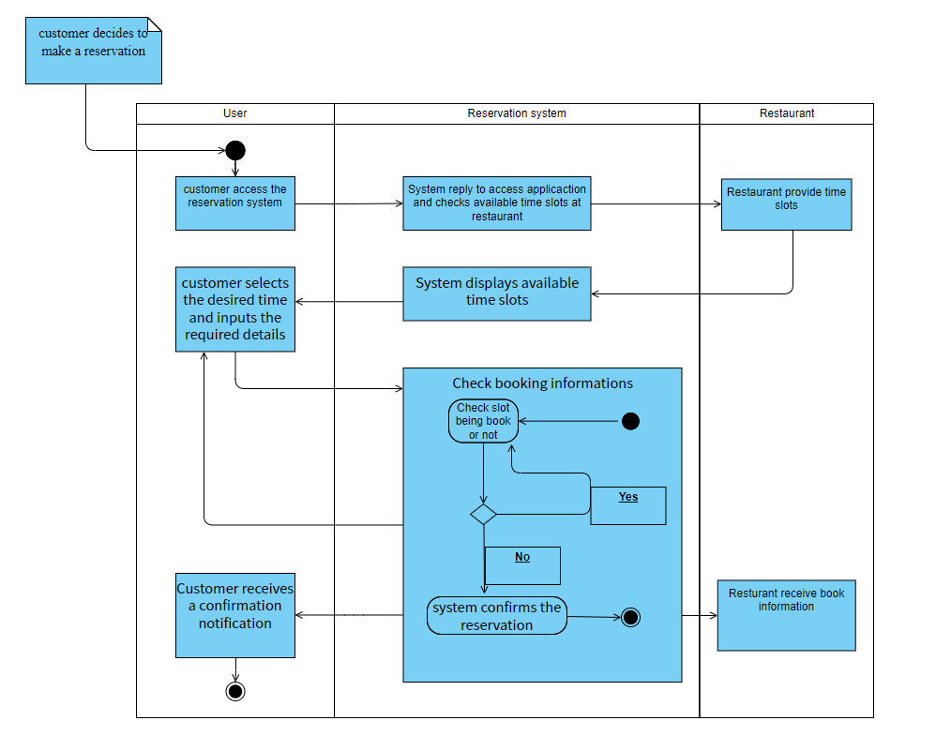
      2. The user will access the Customer Reservation Management feature in the mobile app.
      3. The feature will provide the user with options to either make or cancel their reservation inside the mobile app.
      4. The user can view available reservation times if they choose to make a reservation.
   3. Associated Functional Requirements
      1. Customers **shall** make reservations through the mobile app.
      2. The customers **shall** be provided with available reservation times.
      3. Customers **shall** be able to cancel previous reservations in the app.
   4. Associated Non-Function Requirements
      1. The feature **shall** have a user action response time of less than 2 seconds.
      2. The system **shall** display all up-to-date reservations updated in real time.
2. Digital Menu Creation and Management
   1. Introduction/Purpose of Feature
      1. The Digital Menu Creation and Management feature will allow restaurant staff to add, modify, and remove menu items through the management dashboard.
   2. Stimulus/Response Sequence
      1. 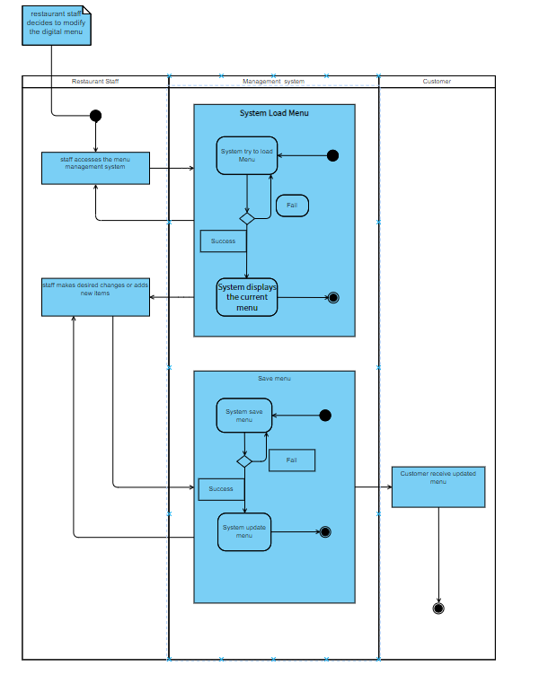
      2. The user will access the Digital Menu Creation and Management feature in the system.
      3. The user will be given a list of current menu items.
      4. The user will be prompted with the option to either add, remove or modify any menu item from the list.
      5. If the user chooses to add a new item to the menu, they will be provided with options based off of available ingredients.
   3. Associated Functional Requirements
      1. Users **shall** update the menu by adding, modifying, or removing items.
      2. Users **shall** be able to log in and access the management dashboard.
      3. The user **shall** be provided with menu items based off of available ingredients.
   4. Associated Non-Function Requirements
      1. The design **shall** have a user-friendly and accessible interface for all users.
      2. The system **shall** not be slowed down while generating menu ideas.
3. Inventory Management
   1. Introduction/Purpose of Feature
      1. The Inventory Management feature will assist by automatically tracking and restocking kitchen inventory based on item availability.
   2. Stimulus/Response Sequence
      1. 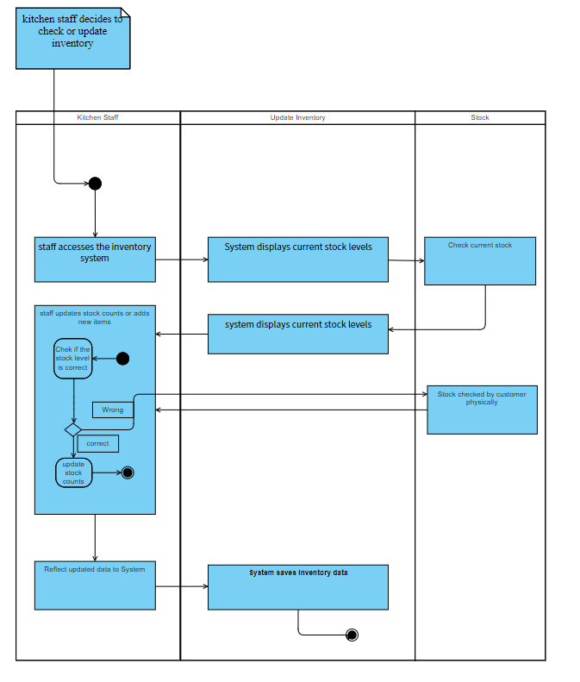
      2. The user will access the Inventory Management feature in the system.
      3. The user will be shown items that were recently automatically restocked.
      4. The user will be prompted to stock new items if they wish to.
   3. Associated Functional Requirements
      1. Users **shall** be able to restock available or new items.
      2. The system **shall** provide the user with ideas of recommended new items to try out based off of previous purchases.
   4. Associated Non-Function Requirements
      1. The system **shall** ensure up-to-date information about stocked ingredients.
      2. The feature **shall** be fast to automatically restock low availability items.
4. Real-Time Table Monitoring
   1. Introduction/Purpose of Feature
      1. The Real-Time Table Monitoring feature will utilize IoT sensors to monitor table occupancy and status in real-time for environment control.
   2. Stimulus/Response Sequence
      1. 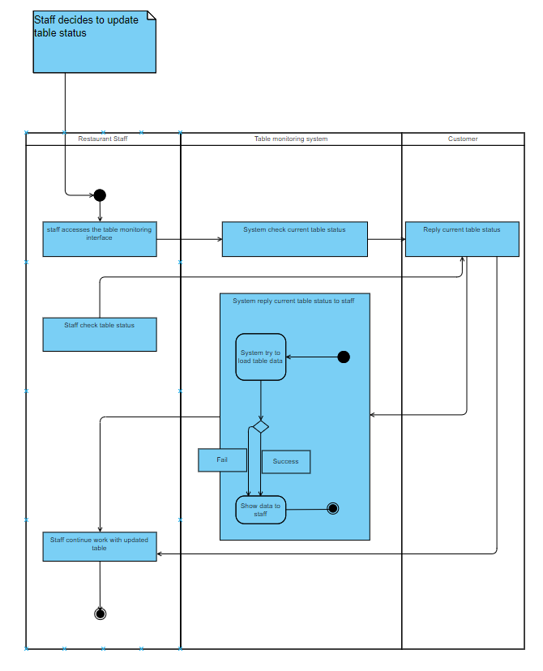
      2. The user will access the Real-Time Table Monitoring feature in the system.
      3. The user will be able to view the current occupied and non-occupied tables.
      4. The user will be able to assign each table a server based off of who is available or not.
      5. If a new table is inputted, the best choice of table will be provided based on server availability and current occupancy.
   3. Associated Functional Requirements
      1. The system **shall** automatically monitor and update table status in real-time.
      2. IoT devices **shall** control restaurant environment settings (e.g., lighting, temperature).
   4. Associated Non-Function Requirements
      1. The system **shall** ensure compatibility with various IoT devices.
      2. The system **shall** be capable of connecting with the Customer Reservation Management feature.
5. Mobile App Integration
   1. Introduction/Purpose of Feature
      1. The Mobile App Integration feature will seamlessly integrate with third-party delivery and map apps for online orders and location-based services.
   2. Stimulus/Response Sequence
      1. 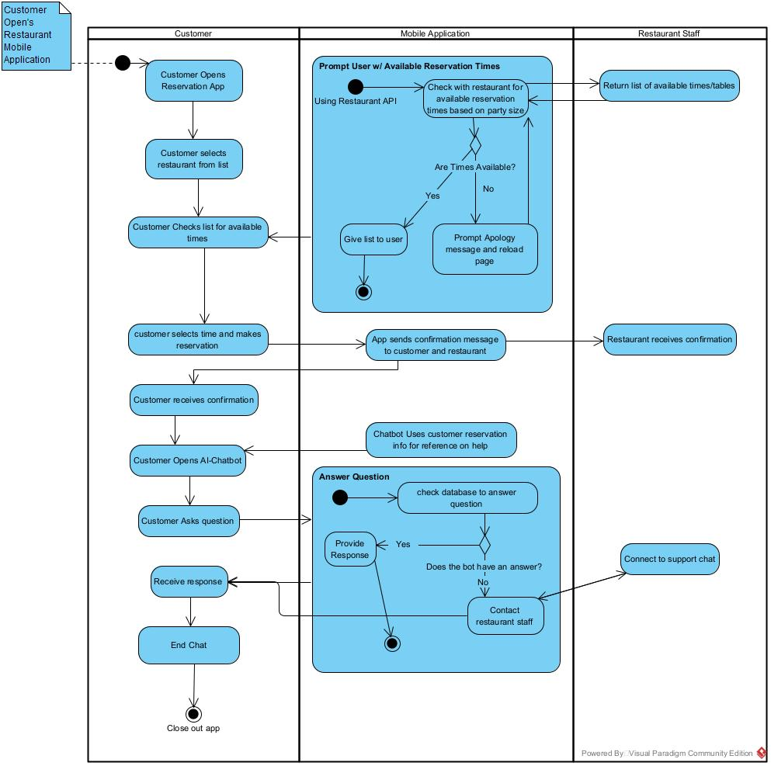The user will access the Mobile App Integration feature in the system.
      2. The user will be given access to see all current orders from various third-party delivery systems.
      3. The feature will show the orders in order from least to most recent.
      4. The feature will support a map system to show the location of delivery drivers and when they will arrive.
   3. Associated Functional Requirements
      1. The system **shall** be integrated with third-party delivery and map apps for online orders.
      2. The system **shall** allow access for the viewer to keep track of online orders.
      3. The orders **shall** be shown in chronological order from least to most recent.
   4. Associated Non-Function Requirements
      1. The system **shall** ensure stable integration with third-party services.
      2. The mobile app **shall** be portable across iOS and Android platforms.
6. AI-Powered Customer Support
   1. Introduction/Purpose of Feature
      1. The AI-Powered Customer Support feature will provide chatbot support, which will provide automated customer support and answer common inquiries.
   2. Stimulus/Response Sequence

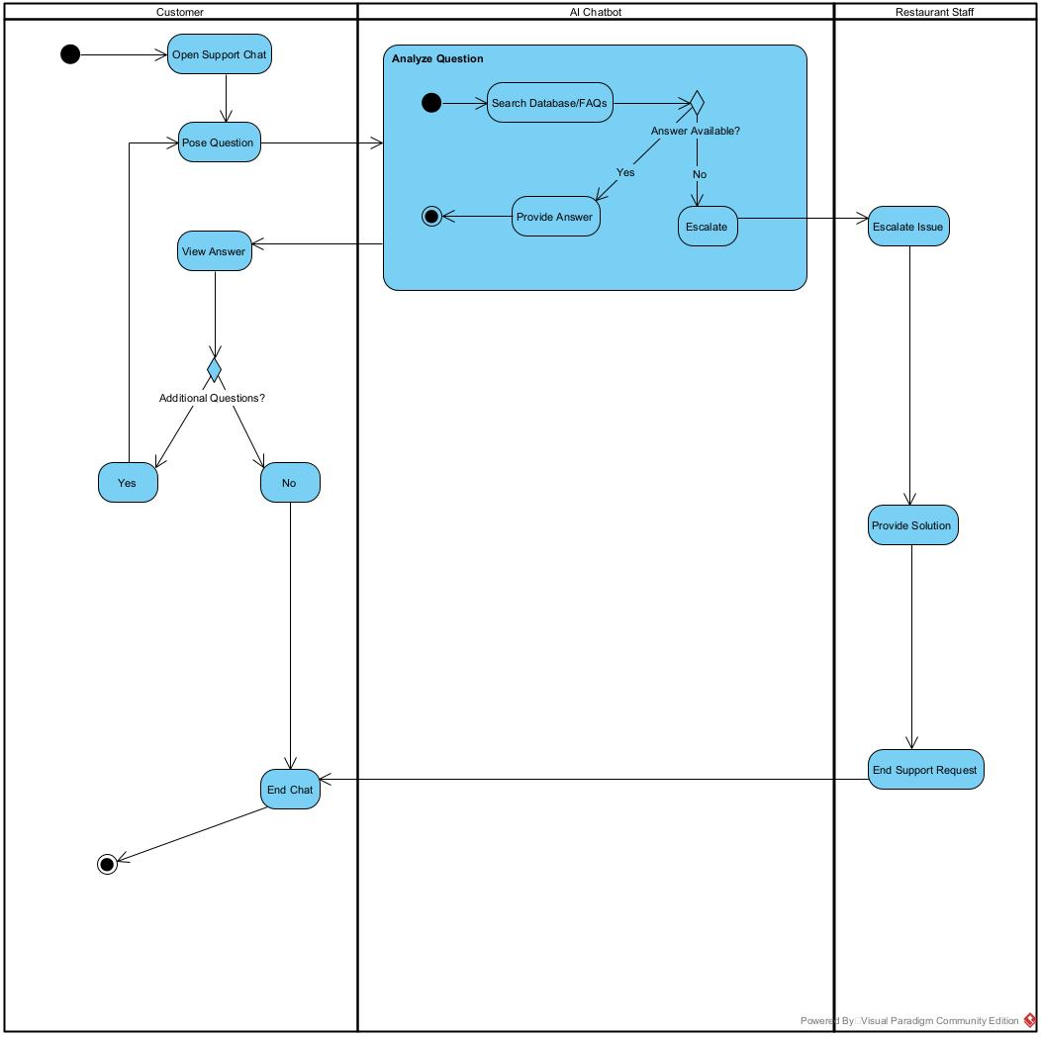

* + 1. The customer will access the AI-Powered Customer Support feature in the system.
    2. The customer will be prompted to ask the AI-Powered Customer Support any questions they have.
    3. The customer will be given an answer from the frequently asked question category if applicable.
    4. If the question is beyond the capabilities of the AI, it will explain the limitations of the AI chatbot to the customer.
  1. Associated Functional Requirements
     1. AI chatbot **shall** assist customers with common inquiries.
     2. The user **shall** be redirected to the frequently asked questions list if their questions are simple and similar to those already asked.
  2. Associated Non-Function Requirements
     1. The system **shall** acknowledge AI chatbot limitations in complex inquiries.
     2. The user **shall** be able to ask any question and be provided with a response, no matter how complex.

1. Payment and Billing Processing
   1. Introduction/Purpose of Feature
      1. The Payment and Billing Processing feature will handle customer payments and billing transactions securely.
   2. Stimulus/Response Sequence

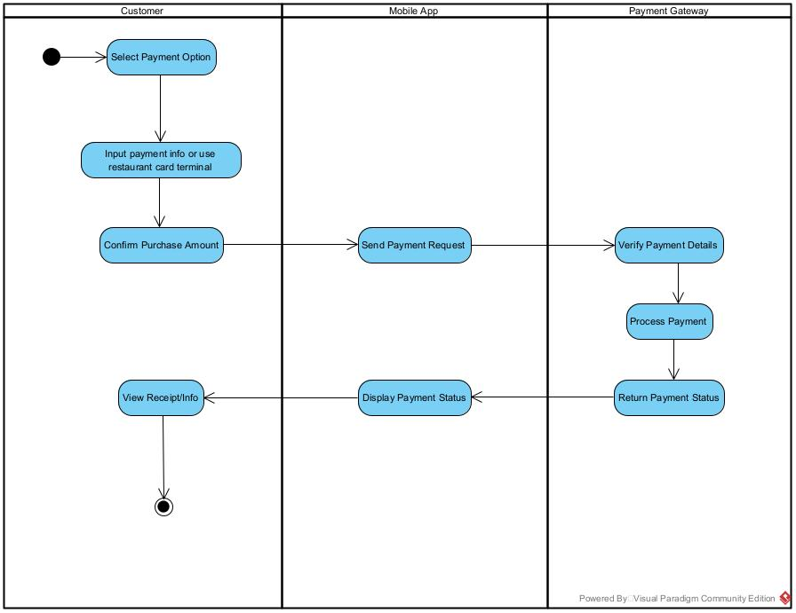

* + 1. The customer will access the Payment and Billing Processing feature in the system.
    2. The customer will have access to current and previous payments.
    3. The customer can view past payments if chosen.
    4. The customer can pay current bills they have through the system.
  1. Associated Functional Requirements
     1. Software **shall** ensure secure payment processing for customer orders.
     2. Software **shall** reassure the customer that information is safe and secure.
  2. Associated Non-Function Requirements
     1. The system **shall** implement robust security measures to protect user data and payments.
     2. The system **shall** be user-friendly in design.